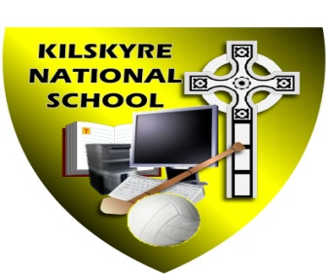#

**Kilskyre National School**

**Kilskyre, Kells, Co. Meath A82DH22**

046-9243947 [kilskyrens@gmail.com](mailto:kilskyrens@gmail.com) www.kilskyrens.com

Roll Number: 01421F Principal: Ailish McKeown

**Annual Admissions Notice for 2024/2025 school year**

A copy of the school’s Admission Policy and the Application Form for admission to Kilskyre N.S may be obtained as follows:

* To download at: www.kilskyrens.com
* On request: By emailing [kilskyrens@gmail.com](mailto:kilskyrens@gmail.com)
* By writing to: Kilskyre Ns, Kilskyre, Kells, Co Meath.

**The following are the dates applicable for admission to Junior Infants**

|  |  |
| --- | --- |
| The school will commence accepting applications for admission on | **Monday, 22nd January, 2024** |
| The school shall cease accepting applications for admission on | **Monday 12th February, 2024** |
| The date by which applicants will be notified of the decision on | **Monday 4th March, 2024** |
| The period within which applicants must confirm acceptance of an offer of admission is | **Monday, 25th March, 2024** |

**Please Note the following:**

* Failure to accept an offer within the prescribed period above may result in the offer being withdrawn
* The school will consider and issue decisions on late applications in accordance with the school’s admission policy
* The number of places being made available in Junior Infants for the school year 2024/2025 is 25